Dual-Node BLE–LoRa Messaging System

Project Report
Prepared by: Guntamukkala Tanuj | Electronics and Communication Engineering | November 2026

Abstract
This project builds a short-message wireless system that works without cellular networks or Wi-Fi. Two senders type short messages on their phones. The messages travel over Bluetooth Low Energy (BLE) to two ESP32 transmitter nodes, then to an ESP32 gateway, across a LoRa radio link at 433.92 MHz to a central unit, and finally by BLE to a third phone that shows them. Four ESP32 boards and two SX1278 LoRa modules make up the hardware, and a custom Android app handles the phone side. BLE is used for cheap local input and LoRa for reach. The report describes the design, the firmware and a custom Android app, Blu-LinQ, handles the phone side, the problems found during development and how they were fixed, the test procedure, and the limitations of the current version.

1. Introduction
In remote areas, disaster zones, large farms and campuses, mobile coverage is often missing, overloaded or too costly. People in these places still need to send quick alerts such as 'Help' or 'All clear'. This project provides a low-cost, infrastructure-free way to relay short text messages from several senders to one monitoring point, using ordinary phones as the input and output devices.

2. Problem Statement
Cellular and Wi-Fi networks cannot be relied on in remote or emergency settings. The aim is to design a system that carries short text alerts from more than one sender to a single receiver without using either network, using inexpensive, widely available hardware.

3. Objectives
- Send short text messages from two phones to a third phone with no cellular or Wi-Fi link.
- Use BLE for the short hops (phone to node, node to gateway, central unit to phone).
- Use LoRa at 433.92 MHz for the longer hop between the gateway and the central unit.
- Label each message with its sender (N1 or N2).
- Keep the total cost low and allow more nodes to be added by changing a node ID.
- Record signal strength (RSSI) at the central unit to study range.

4. System Architecture
Phone 1 --BLE--> Node A1 --BLE--+
+--> Gateway --LoRa 433.92 MHz--> Central Unit --BLE--> Phone 3
Phone 2 --BLE--> Node A2 --BLE--+

The system has five parts:
- Phones 1 and 2 (senders): connect to a node and type the message.
- Node A1 and Node A2: receive the text over BLE and broadcast it as a BLE advertisement tagged with the node ID.
- Gateway: scans for the node advertisements, removes duplicates, queues the messages and sends each one as a LoRa packet.
- Central Unit: receives the LoRa packet, checks it and forwards it to Phone 3 as a BLE notification.
- Phone 3 (receiver): shows the labelled message through the Android app.
The radios are separated by job: BLE is cheap and phones already support it, while LoRa gives longer reach.

5. Hardware
Component | Quantity | Purpose
ESP32 DevKit V1 (30-pin) | 4 | Node A1, Node A2, Gateway, Central Unit
LoRa SX1278 module (Ra-01/Ra-02, 433 MHz) | 2 | Gateway and Central Unit
433 MHz antenna (about 17.3 cm wire, spring or SMA rubber-duck) | 2 | One per LoRa module
USB power source (power bank, charger or laptop port) | 4 | One per board
100 µF capacitor (optional) | 2 | Across each LoRa module supply
LoRa module wiring (Gateway and Central Unit, as used in the firmware):
SX1278 pin | ESP32 pin
NSS (SS) | GPIO 5
RST | GPIO 14
DIO0 | GPIO 2
SCK | GPIO 18
MISO | GPIO 19
MOSI | GPIO 23
VCC | 3.3 V
GND | GND
An antenna must always be attached before transmitting, because a transmitting SX1278 without one can be damaged.

6. Circuit Diagram
The Gateway and the Central Unit each connect one SX1278 LoRa module to an ESP32 using the same wiring, listed in the pin table in Section 5. Node A1 and Node A2 need no extra wiring: each is an ESP32 powered over USB.
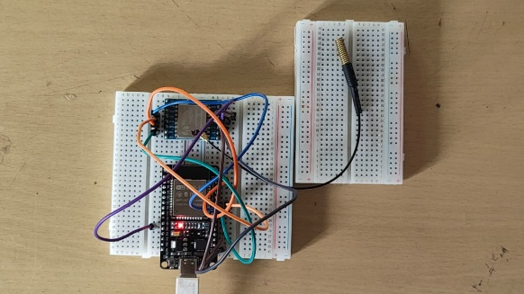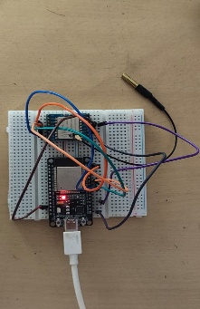
Figure 6.1: The left circuit shows the central unit circuit connection, and the right side shows the gate way circuit
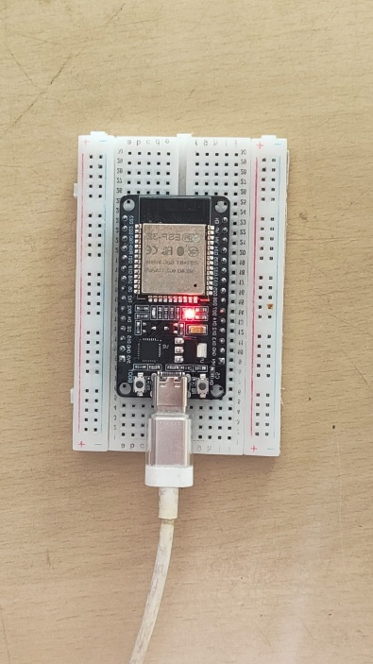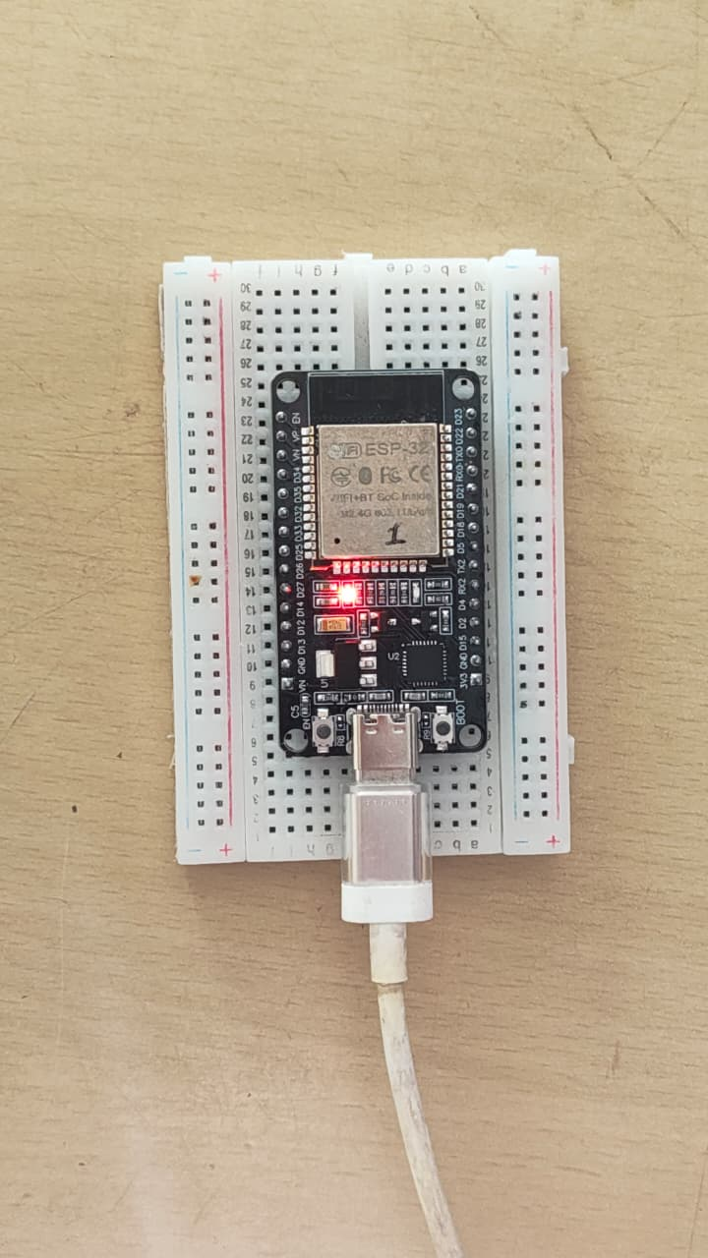
Figure 6.2: The left circuit shows the Node A circuit connection, and the right side shows the Node B circuit

7. Software Design

7.1 Transmitter nodes (Node A1 and Node A2)
Both nodes run the same firmware. Only the node ID and the BLE name differ (Node_A1_Input with ID 1, Node_B2_Input with ID 2). Each node:
- exposes the Nordic UART Service (UUID 6E400001-B5A3-F393-E0A9-E50E24DCCA9E), with a write characteristic (6E400002) that receives text from the phone and a notify characteristic (6E400003);
- accepts both 'Write' and 'Write Without Response', because many phone apps use the second;
- trims the text, keeps at most 17 characters and increments a sequence number;
- broadcasts the message as manufacturer data in a BLE advertisement, then returns to normal advertising;
- restarts advertising after a phone disconnects.

7.2 Gateway
The gateway runs a BLE scanner and a LoRa transmitter on one ESP32. It:
- scans passively and accepts duplicate advertisements from the same device address;
- keeps only packets with the marker 0xAA and a node ID of 1 or 2;
- compares the sequence number with the last one seen from that node to drop repeats;
- places new messages in a ten-slot queue;
- sends each queued message as a LoRa packet at 433.92 MHz, 10 dBm, with CRC enabled and sync word 0xF3.

7.3 Central Unit
The central unit starts BLE first, so the phone can always find it, and then starts LoRa. It:
- advertises as Central Unit and offers the notify characteristic to Phone 3;
- reads the LoRa chip version register at start-up (a value of 0x12 means the SX1278 is wired correctly) and retries LoRa every 5 seconds if it fails, without blocking BLE;
- keeps the LoRa radio in continuous receive mode;
- parses the packet, builds the label (for example N1: HELP), and sends it to Phone 3 as a BLE notification;
- prints RSSI and SNR for every packet, which is used for the range of tests.

7.4 Android app
The Android app, Blu-LinQ, is built with Kotlin and Jetpack Compose. Blu-LinQ connects a phone to the transmitter nodes and to the Central Unit over BLE, sends and receives the short messages, and logs them. Its screens are the central unit console, transmitters, devices, logs and dashboard. For each device it scans for the real BLE name, connects over GATT, discovers the Nordic UART Service and, for the central unit, subscribes to notifications by writing to the descriptor 0x2902. Incoming text is split at the colon, N1 is shown as 'Source Node A' and N2 as 'Source Node B', and messages that contain words such as SOS, HELP or MAYDAY are flagged as emergencies. Messages are stored in a local database for the log screen and CSV export.

8. Application Interface
Blu-LinQ is an Android app used to operate the system. It connects a phone to the nodes and to the Central Unit and shows the messages received. The figures below show its main screens.
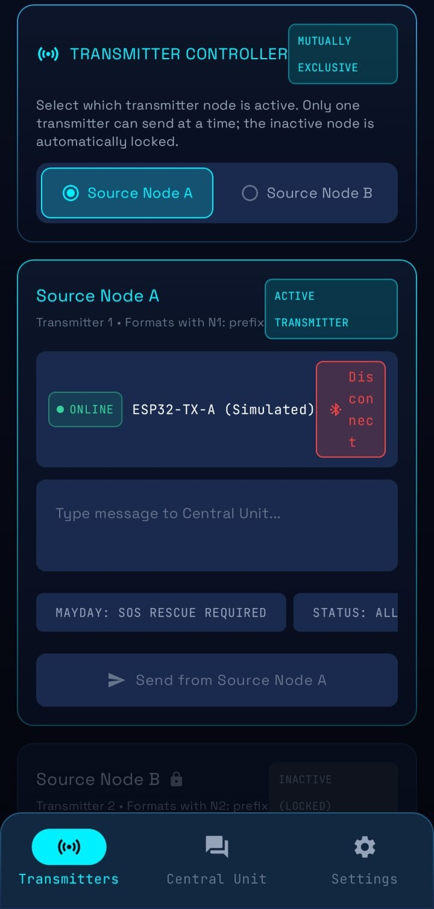
Figure 8.1: Blu-LinQ receiver screen, connecting the node A and the Central Unit

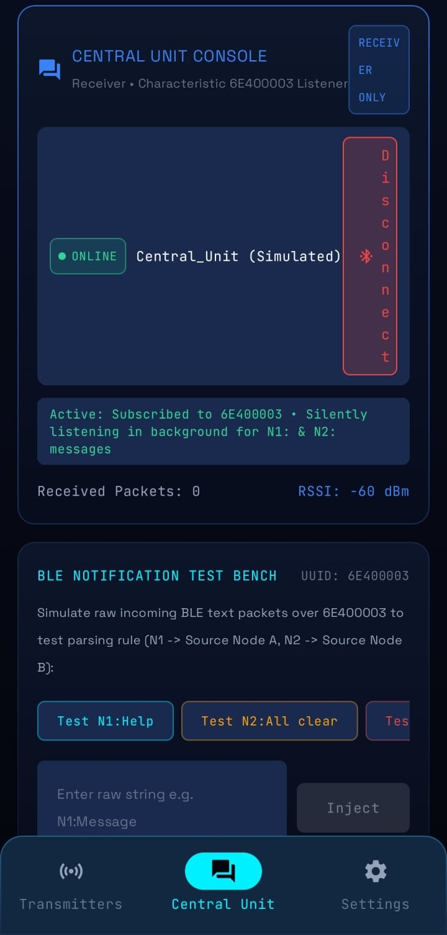
Figure 8.2: Devices screen, connecting nodes and Central Unit
The Central Unit screen shows the messages received, newest first. Each card gives the sender (Source Node A or B), the message text, the time received, the signal strength in dBm, the delay in ms and the GPS position. Messages are sorted by the N1: and N2: label added by the Central Unit.

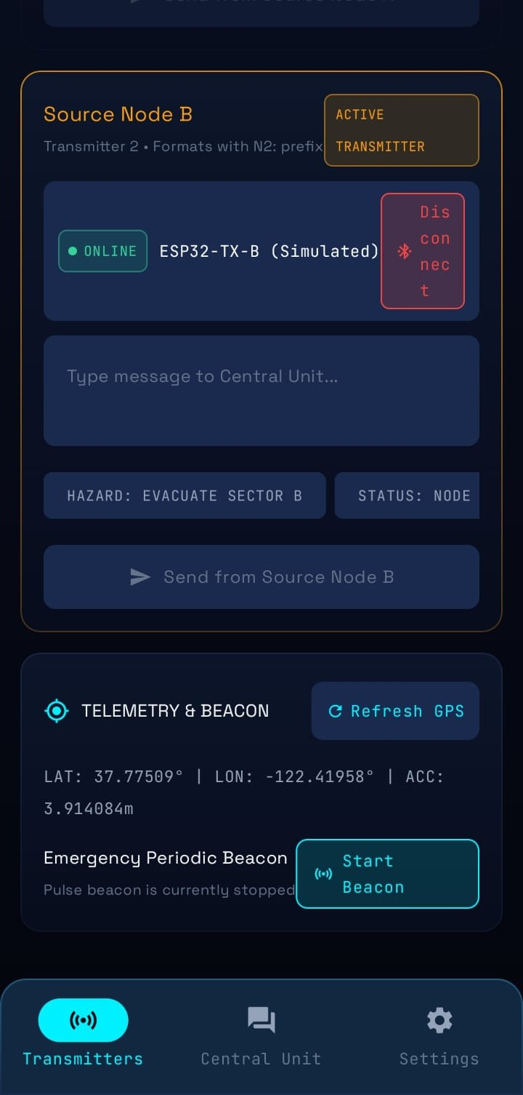
Figure 8.3: Devices screen, connecting node B and the Central Unit
The Transmitters screen has one card per sender node. The Source Node B card shows its connection status, a message box and ready-made alert buttons such as “HAZARD: EVACUATE SECTOR B”. Below the card, the Telemetry & Beacon panel shows the phone’s GPS position and a button that sends a periodic emergency beacon.

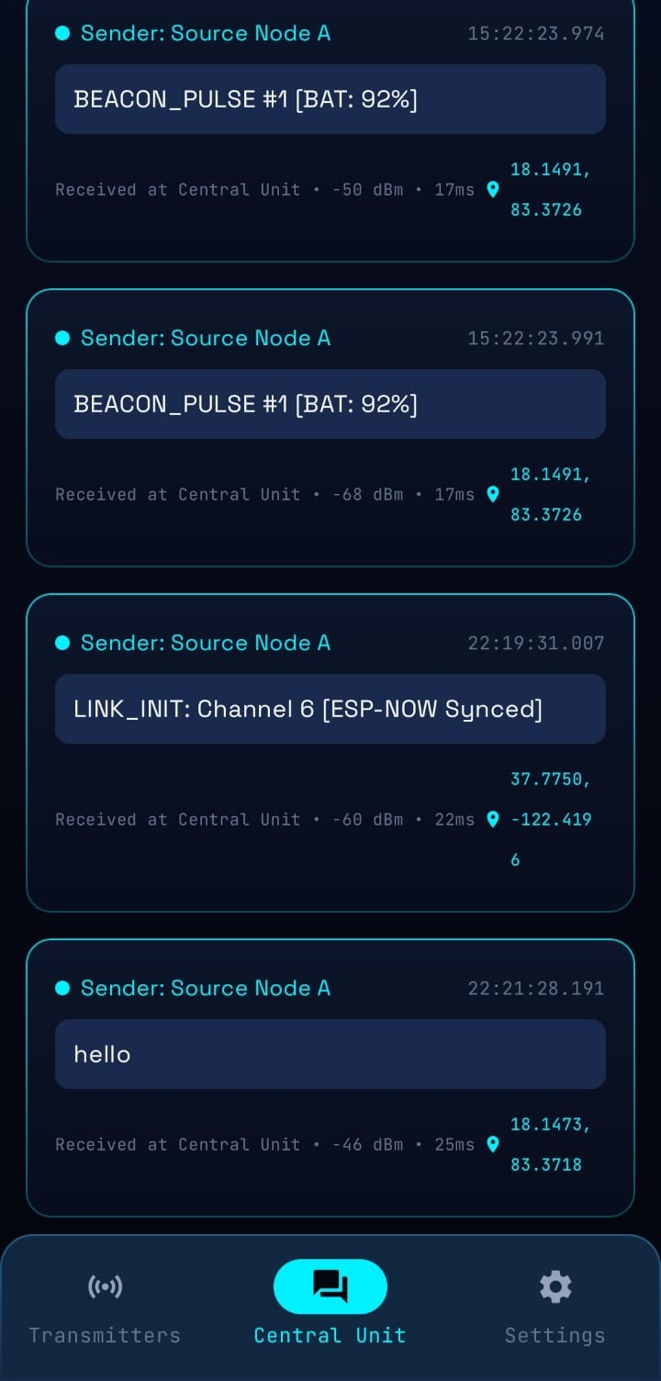
Figure 8.4: Receiver screen, showing messages labelled by sender
The Central Unit console connects to the receiver and listens to the notification characteristic 6E400003 for N1: and N2: messages. It shows the packet count and signal strength. A test bench below lets you inject sample packets such as “N1: Help” to check the message parsing without hardware.

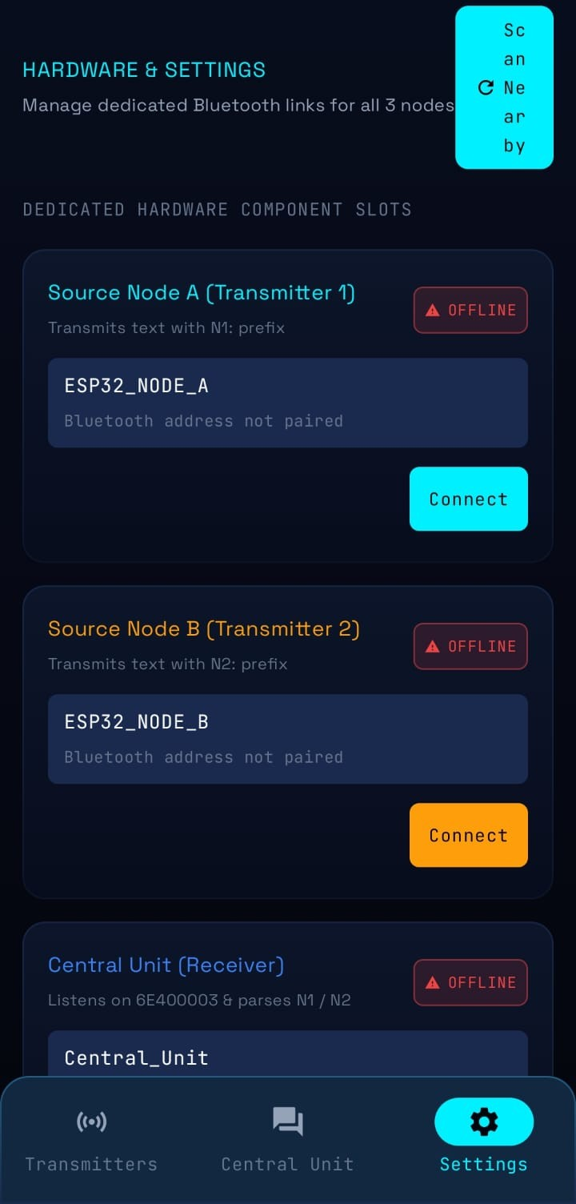
Figure 8.5: settings screen

9. Message Flow and Packet Formats
- The user opens the app (or a BLE terminal app) on Phone 1 and connects to the node.
- The user types a message, which is written to the node's writing characteristic.
- The node prints it on its Serial Monitor and broadcasts it as a BLE advertisement.
- The gateway scans, filters, removes duplicates and queues the message.
- The gateway sends it as a LoRa packet.
- The central unit receives the packet, checks CRC and sync word, and parses the sender ID and text.
- The central unit labels the message and notifies Phone 3.
Hop | Format
Node advertisement (manufacturer data) | 0xFF 0xFF (company ID), 0xAA (marker), node ID, sequence number, then up to 17 text characters
LoRa packet | N,<nodeID>,<message>
Notification to Phone 3 | N<nodeID>:<message>, at most 20 characters
LoRa settings: 433.92 MHz, sync word 0xF3, CRC enabled, transmit power 10 dBm.

10. Regulatory Considerations (India)
- The 433.05–434.79 MHz band is licence-exempt for low-power devices, but only at 10 mW ERP, with a 10% duty cycle and indoor use.
- The code caps transmit power at 10 dBm. With a higher-gain antenna, the power should be lowered (to about 8 dBm for a 3 dBi antenna).
- The system transmits only when a message is sent, so the duty cycle is naturally low.
- For true multi-kilometer outdoor range, the 865–867 MHz band (up to 1 W ERP) is the legal option. It needs an 868 MHz-variant module tuned to 865.0625 MHz. The firmware architecture stays the same, with only a frequency change.

11. Testing Procedure
- Flash and power the Central Unit and Gateway first. Both Serial Monitors should show 'LoRa ready'.
- Connect Phone 3 to Central Unit and enable notifications.
- Flash Node A1, connect Phone 1, send a message, and confirm that the Gateway logs 'BLE RX' and then 'LoRa TX', and the Central Unit logs 'LoRa RX'.
- Repeat with Node A2 and check that the label changes to N2.
- Gradually increase the distance between the Gateway and the Central Unit and record the RSSI that the Central Unit prints.

12. Applications
- Emergency or SOS alerts for hikers, campuses and remote workers.
- Status messages between teams on large sites such as farms, construction sites and events.
- Disaster response when cell towers are down.
- Rural and off-grid communication.
- Industrial alerts from factory floors to a control room.
- A low-cost, terrestrial alternative to satellite messengers.

13. Advantages
- Works with no cellular or Wi-Fi infrastructure.
- Low cost, about ₹4,500–7,500 for all four boards plus two LoRa modules.
- Uses ordinary phones for input and output, so no custom hardware interface is needed.
- Scales to more nodes by flashing another board with a new node ID.
- Separates the radios by job: BLE for cheap local input and LoRa for reach.

14. Limitations
- At 433 MHz and 10 mW, realistic range is tens to a few hundred meters, not kilometers.
- Messages are limited to 17 characters.
- Communication is one-way, from the nodes to the central unit. There is no reply path.
- The gateway handles BLE scanning and LoRa transmission on one chip, so a busy moment can occasionally miss a message.
- Phone 3 must have notifications that enable us to see anything.
- A BLE advertisement carries no delivery guarantee, and there are no acknowledgements or retries on the LoRa link.
- The signal-strength graphs in the app use demonstration values and do not show real LoRa readings.
- The firmware and app changes have not yet been fully verified on the final hardware.

15. Conclusion
The project shows that short messages can be carried from two phones to a third using BLE for the local hops and LoRa for the longer hop, with no cellular or Wi-Fi network. The architecture is simple, cheap and easy to extend with more nodes. Development exposed several practical issues in BLE advertising, connection stability, LoRa receive mode and the phone app, and each has a documented fix. The main remaining work is to confirm the full chain on the final hardware, record range measurements, and extend the system with acknowledgements, two-way messaging and a license-compliant long-range band.

References
- Semtech, SX1276/77/78/79 datasheet.
- Espressif Systems, ESP32 technical reference and Arduino-ESP32 BLE library documentation.
- Nordic Semiconductor, Nordic UART Service (NUS) specification.
- Arduino LoRa library for SX127x modules (Sandeep Mistry).
- Government of India, notification on license-exempt frequency bands (433 MHz and 865–867 MHz).

